RGB led

Overview

This course will use the Raspberry Pi GPIO pins to light RGB led.

Experimental Materials

RaspberryPi *1

breadboard *1

RGB led *1

Dupont Line

Ready to work

1. Install python interpreter in your Raspberry Pi system

2. Install the RPi.GPIO library in your Raspberry Pi system

3. Install the wiringPi library in your Raspberry Pi system

See the attached "Installing a Python Interpreter and Corresponding Libraries in a Raspberry Pi System" for details.

Product Description

Brief Introduction

The RGB LED module is made of a plug-in full-color LED. Through the PWM voltage input of R, G, B three pins, the intensity of the three primary colors (red/blue/green) can be adjusted to achieve the full-color color mixing effect. It is generally used in KTV, stage, building and other environments and plays a role of lighting decoration. You can use the Raspberry Pi to control the module for cool lighting effects.

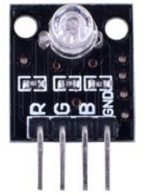

Characteristic parameters

◆ Use plug-in full-color LED

◆Adjust the three primary colors by PWM can be mixed to get different colors

◆Working voltage: 5V

◆Drive mode: Common cathode drive

Wiring diagram

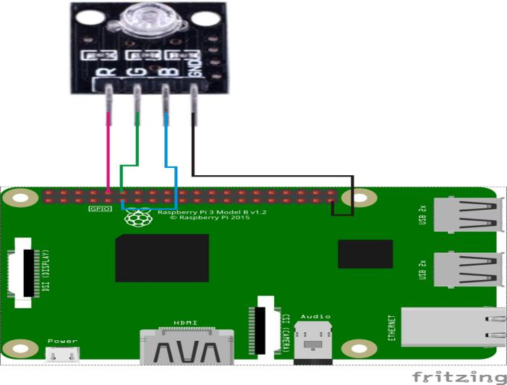

Sample code

1. Python code

#!/usr/bin/env python

import RPi.GPIO as GPIO

import time

colors = [0xFF0000, 0x00FF00, 0x0000FF, 0xFFFF00, 0xFF00FF, 0x00FFFF]

pins = {'pin_R':10, 'pin_G':12, 'pin_B':11} # pins is a dict

GPIO.setmode(GPIO.BOARD) # Numbers GPIOs by physical location

for i in pins:

GPIO.setup(pins[i], GPIO.OUT) # Set pins' mode is output

p_R = GPIO.PWM(pins['pin_R'], 2000) # set Frequece to 2KHz

p_G = GPIO.PWM(pins['pin_G'], 2000)

p_B = GPIO.PWM(pins['pin_B'], 2000)

p_R.start(0) # Initial duty Cycle = 0(leds off)

p_G.start(0)

p_B.start(0)

def map(x, in_min, in_max, out_min, out_max):

return (x - in_min) * (out_max - out_min) / (in_max - in_min) + out_min

def setColor(col):

R_val = (col & 0xFF0000) >> 16

G_val = (col & 0x00FF00) >> 8

B_val = (col & 0x0000FF) >> 0

R_val = map(R_val, 0, 255, 0, 100)

G_val = map(G_val, 0, 255, 0, 100)

B_val = map(B_val, 0, 255, 0, 100)

p_R.ChangeDutyCycle(R_val) # Change duty cycle

p_G.ChangeDutyCycle(G_val)

p_B.ChangeDutyCycle(B_val)

try:

while True:

for col in colors:

setColor(col)

time.sleep(0.5)

except KeyboardInterrupt:

p_R.stop()

p_G.stop()

p_B.stop()

for i in pins:

GPIO.output(pins[i], GPIO.HIGH) # Turn off all leds

GPIO.cleanup()

2. C code

#include <wiringPi.h>

#include <softPwm.h>

#include <stdio.h>

typedef unsigned char uchar;

#define LedPinRed 16

#define LedPinGreen 1

#define LedPinBlue 0

void ledInit(void)

{

softPwmCreate(LedPinRed, 0, 100);

softPwmCreate(LedPinGreen,0, 100);

softPwmCreate(LedPinBlue, 0, 100);

}

uchar map(uchar val, uchar in_min, uchar in_max, uchar out_min, uchar out_max)

{

uchar tmp = 0;

tmp = (val - in_min) * (out_max - out_min) / (in_max - in_min) + out_min;

return tmp;

}

void ledColorSet(uchar r_val, uchar g_val, uchar b_val)

{

uchar R_val, G_val, B_val;

R_val = map(r_val, 0, 255, 0, 100);

G_val = map(g_val, 0, 255, 0, 100);

B_val = map(b_val, 0, 255, 0, 100);

softPwmWrite(LedPinRed, R_val);

softPwmWrite(LedPinGreen, G_val);

softPwmWrite(LedPinBlue, B_val);

}

int main(void)

{

int i;

if(wiringPiSetup() == -1)

{

printf("setup wiringPi failed !");

return 1;

}

ledInit();

while(1)

{

ledColorSet(0xff,0x00,0x00); //red

delay(1000);

ledColorSet(0x00,0xff,0x00); //green

delay(1000);

ledColorSet(0x00,0x00,0xff); //Blue

delay(1000);

ledColorSet(0xff,0xff,0x00); //yellow

delay(1000);

ledColorSet(0xff,0x00,0xff); //Magenta

delay(1000);

ledColorSet(0x00,0xff,0xff); //Cyan

delay(1000);

}

return 0;

}

Experimental phenomena

RGB led will light red, green, blue, yellow, magenta, and cyan lights in cycle.